HE
Job Aid
Manual Rerating ER/BDA

Note: This template includes guidance to assist with completing each section. All instructional text \is intended for reference during drafting and must be removed before distributing the document.
For queries or feedback on this template, write to COE_KnowledgeMgmt@fedex.com.

Document Control Information

Author(s) | Aadya / Forum / Vishal
Issued on | Date when the document was first rolled out
Last updated | 15/06/2026
Approver(s) | Individual(s) who formally approved the document
Process owner(s) | Udit Mittal
Version | v1.0
Keywords | Rerating

Table of Contents
- Task summary & purpose
- Prerequisites/tools required
- Step-by-step procedure
- Troubleshooting
- Additional information
  - Tips & tricks
  - Reference links
  - FAQ
- Revision history

1. Task Summary & Purpose
Manual Rating refers to the calculation of shipping charges for complex, non-standard, or exceptional shipments where standard rate structures do not apply and specific adjustments are required.
Manual rating ensures:
  - Accuracy in billing
  - Flexibility to accommodate special customer agreements or unique service needs.
  - Customer satisfaction
  - Revenue protection by preventing undercharging or overcharging
2. Prerequisites / Tools Required
- Database access – Access to the required schemas. Reach out to forum.bhanushali@fedex.com to get the list.
- BDA tool site BDA Automated Tools - Tools - All Documents – Download the below templates from here and save it in your OneDrive
- Shipment Detail Template (June 2026).xlsm – To pull the base shipment data.
- Surcharge Discount Comparison Template – To pull surcharges data
- CPM – To validate discounts against the agreement
3. Step-by-step Procedure
Rate comparison

1. Extract Shipment Data
- Use the Shipment Detail Template to retrieve shipment data using the applicable CHT ID, timeframe, and other required parameters specified in the request. An example of the filled fields is as below.
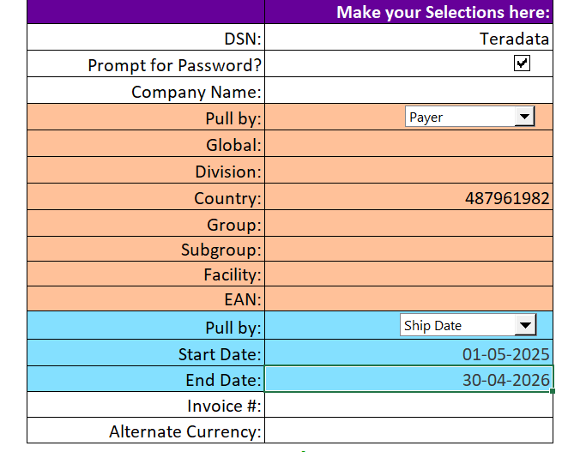
- The extracted shipment data will serve as the base dataset for the rate comparison analysis.

2. Cleanse Shipment Data
Remove all rows meeting any of the following conditions:
Field | Exclusion Criteria
Product Name | Services not under review (e.g., F1R, Pickup, International, Freight, etc.)
USD List Freight Charge | Value is $0 or blank (-)
Zone | Non-US Domestic zones (e.g., Zone 51, Zone 00)
Pieces | Greater than 1
Origin Region | Not US
Destination Region | Not US

3. Retain Required Columns
Keep only the following columns in the shipment dataset:
Tracking Number, Product Name, Pay Type, Package Type, Rated Weight (Lbs), Pieces, Shipments, Zone, Payer Global Name, Col with level id used to pull data, OpCo, Invoice Date, Ship Date, USD List Freight Charge, USD Discount Amount, USD Net Transportation Amount, Origin Region, Destination Region, Original Weight (Lbs), Length, Width, Height, DIM Divisor

4. Rate Shipment Data
- Before proceeding with the re-rating, standardize the Zone values in the shipment data by replacing any alphabetical zone codes with their corresponding numeric zone values, as defined in the zone mapping reference below. This ensures consistency and accurate rate matching during the rating process.
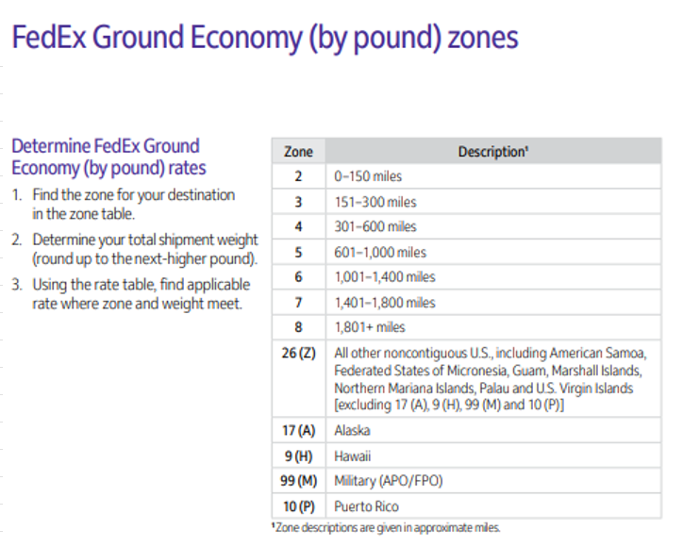
- Filter the shipment data by Product Name (service) and rate each service individually using the Current and Proposed Net Rate Sheets provided by Sales, ensuring that the corresponding service is selected in the rate sheets before performing the rate lookup
- Use VLOOKUP and MATCH functions based on Rated Weight and Zone to retrieve the applicable rate from the corresponding Net Rate Sheets according to the shipment's Package Type.
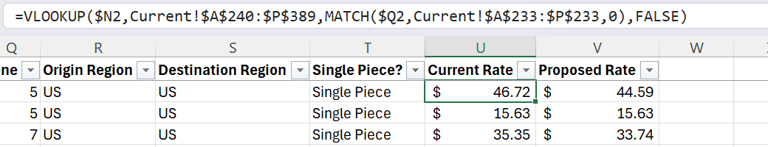

Special Handling Rules
Envelope/Letter Shipments
- All Envelope/Letter shipments should be rated using the 1 lb Envelope rate, regardless of whether the Rated Weight is greater than or less than 1 lb.
- To facilitate rate lookups, insert a "1 lb" value in the Weight column before the rates within the Envelope section of the Net Rate Sheets. If a shipment's Rated Weight differs from 1 lb, populate the applicable rate by pasting the corresponding Envelope rate for the shipment's zone directly from the Net Rate Sheet.
Pak Shipments
- If the Rated Weight of any Pak shipment exceeds 2 lbs, rate the shipment using Customer Packaging rates.
- If Pak rates are unavailable in the Net Rate Sheet, use Customer Packaging rates.
First Overnight (FO) Shipments
- If Proposed Rates are unavailable and both Net Rate Sheets are from the same year, use the Current Rates as the Proposed Rates.
- If the Current and Proposed Net Rate Sheets are from different years, use FO List Rates to rate the shipments.
Missing Rates
- If applicable Net Rates cannot be identified after applying the above rules, exclude those shipment records from the analysis.

5. Create Summary Tab
- Once Current and Proposed Rates have been assigned to all applicable shipments, create a new worksheet named Summary.

6. Generate Pivot Table
- Create a Pivot Table from the shipment data within the Summary tab.
- Include the following fields in the output:
  - Service
  - Shipments
  - Rated Weight
  - Current Rate
  - Proposed Rate

7. Prepare Summary Table
- Create a Summary Table adjacent to or below the Pivot Table.
- Copy and paste the Pivot Table results into the Summary Table.
- Arrange services in the required reporting order as specified in the reference template.
- Add an Impact column that calculates the difference between Proposed and Current Rates.
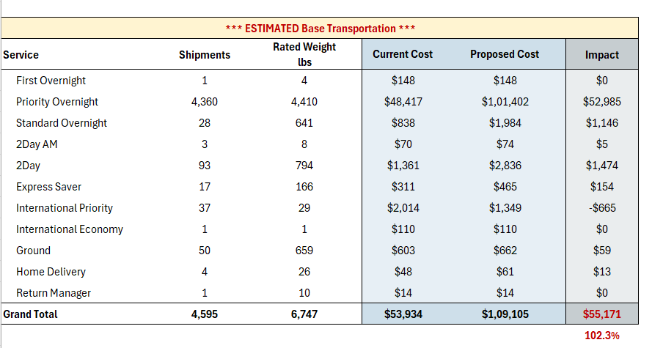

8. Add Supporting Information
- Display the shipment data’s date range at the top of the Summary tab.
- Include any notes regarding shipment data exclusions, assumptions, or adjustments made during the analysis.
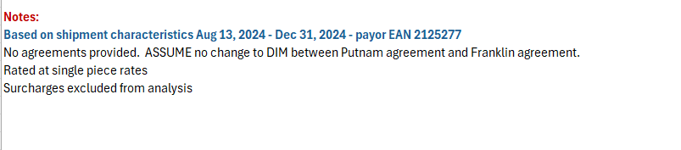

9. Add Disclaimer
- Insert the approved disclaimer directly below the Summary Table.
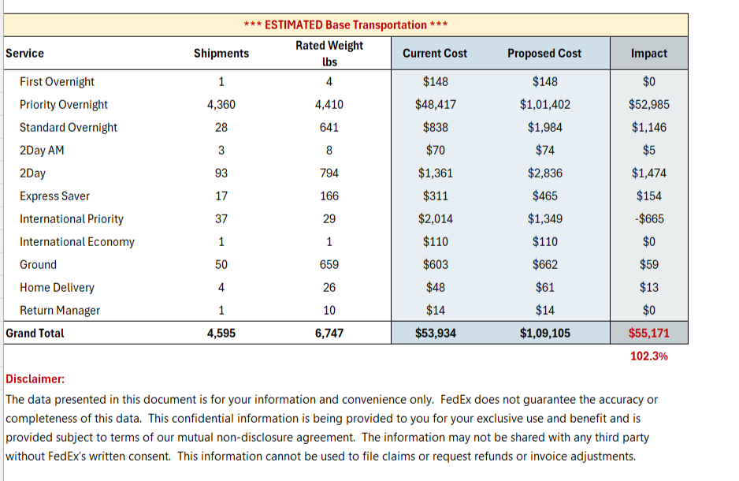

10. Formatting Standards
Apply the following formatting standards to the Summary Table:
- Display Impact percentages with one decimal place.
- Display monetary values with a dollar sign ($) and zero decimal places.
- Follow the US numbering convention for comma separators.
- Ensure formatting is consistent across all summary outputs.

- Apply what you've learned and give it a try here:
  - EDUCATION - COE Manual Rating
  - COE Education - Multiple Services exercise, Day 5

Heavyweight Shipment Re-Rating (Packages > 150 lbs)
For shipments with a Rated Weight greater than 150 lbs, standard net rate sheet rates cannot be directly applied. Use the following process:
- In both the Current and Proposed Net Rate Sheets, insert an additional row immediately below the 150 lb rate row for the applicable service.
- Calculate a Per-Pound Rate for each zone by dividing the 150 lb rate by 150.
Per-Pound Rate = 150 lbs Rate ÷ 150
This additional row serves as the basis for rating shipments exceeding 150 lbs.
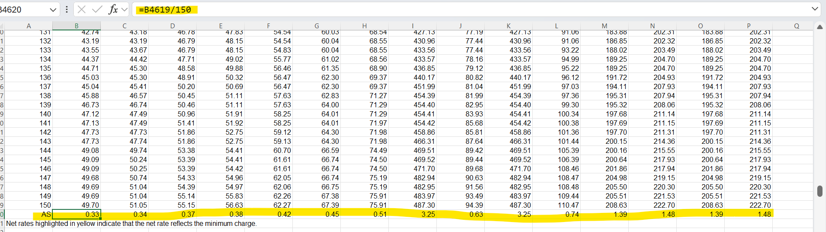
- For heavyweight shipments, perform the rate lookup using the calculated Per-Pound Rate for the applicable zone.
- Calculate the shipment rate by multiplying the Per-Pound Rate by the shipment's Rated Weight.
Shipment Rate = Per-Pound Rate × Rated Weight
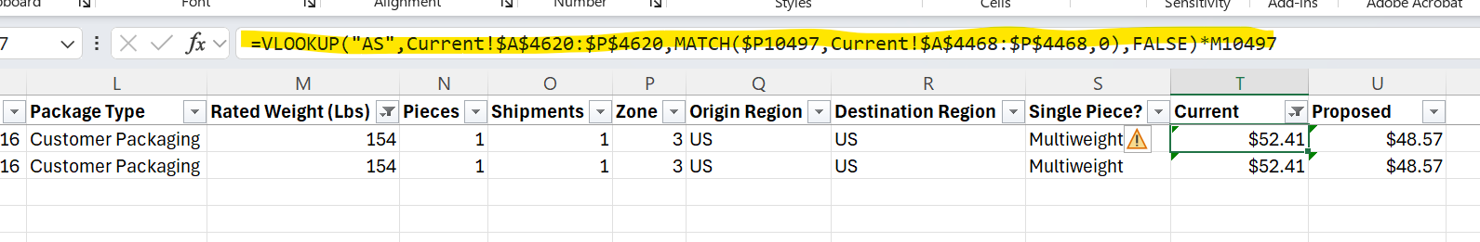
- Repeat the process separately for both the Current and Proposed Net Rate Sheets to obtain the respective rates.
- For Express Heavyweight shipments, locate the heavyweight rate table which is generally placed below the standard rate table of specific service. Use an approximate match lookup on the Rated Weight and Zone to retrieve the applicable rate.
VLOOKUP(Rated weight, Lookup range, zone, true)
Freight Service Re-Rating
For Freight Services (e.g., 1Day Freight, 2Day Freight, 3Day Freight, etc.), rates are typically provided in weight ranges rather than individual weights. Use the following process to rate freight shipments:
- Identify the applicable Freight Service rate table within the Current and Proposed Net Rate Sheets.
- Insert a helper column immediately to the right of the Weight Range column.
- Populate this helper column with the starting weight value of each corresponding weight range. This will be used as the lookup value reference for freight rate calculations.
- When performing the rate lookup:
  - Use the helper column containing the starting weights as the first column of the lookup range.
  - Select the entire freight rate table, beginning from the helper column through the last zone column.
  - Do not include the zone header row in the lookup range.
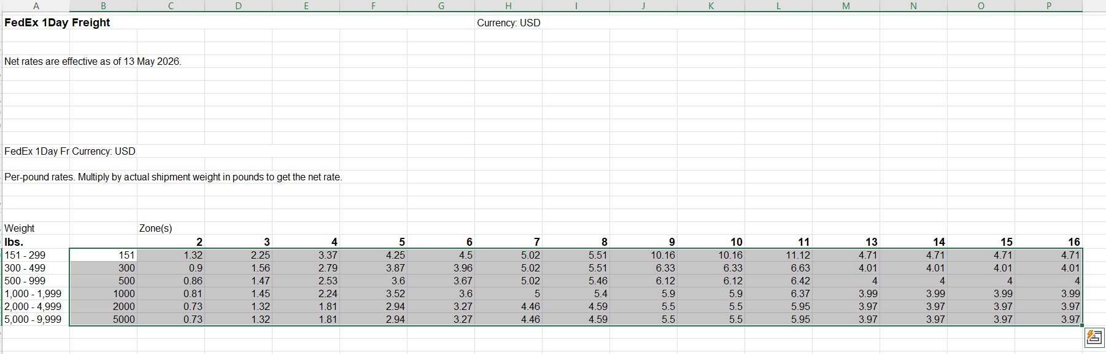
- Use the shipment's Rated Weight as the lookup value and the shipment's Zone as the column index to retrieve the applicable freight rate from the rate sheet.
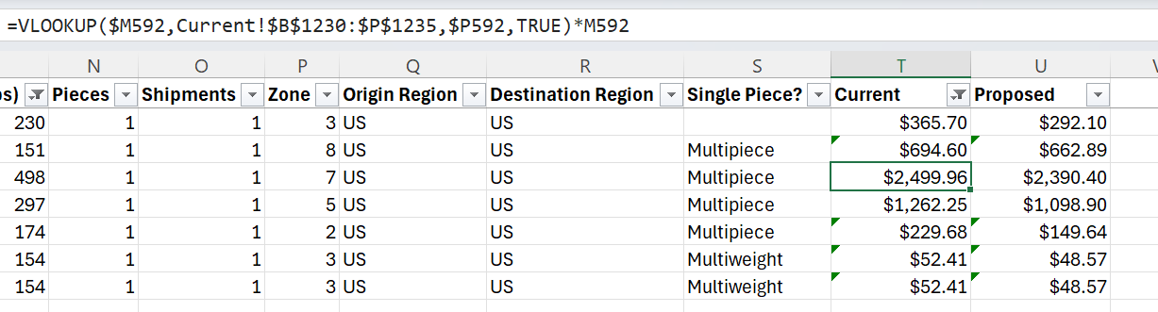
- Repeat the same process for both the Current and Proposed Net Rate Sheets to obtain the respective freight rates.
Note: Freight shipment rates are determined based on the weight range in which the shipment's Rated Weight falls and the corresponding shipment zone.

- Apply what you've learned and give it a try here:
  - Reliance new rate comparison
  - Archer Aviation - COE exercise

DIM changes and MBW
Whenever a DIM factor changes request comes the following steps needs to be followed: -
- DIM Change Analysis

  - Pull the data from the Shipment Detail Template with required information (Country ID, payer/shipper account, shipment/invoice start and end data) (Refer Rate Comparison step for Data Extraction)

  - Construct new columns by using below formulas:
    - L = MAX (existing Length,Width and Height Columns)
    - W = MEDIAN (existing Length,Width and Height Columns)
    - H = MIN (existing Length,Width and Height Columns)
    - New DIM Volume = Newly calculated L * W * H
    - New Current DIM Weight = New DIM Volume/existing DIM factor
    - Current Rated Weight = Round (MAX (existing actual Weight, New Current DIM Weight),0)
    - Proposed DIM weight = New DIM Volume/proposed DIM Factor
    - Proposed Rated Weight = Round (MAX (existing actual Weight, Proposed DIM Weight),0)
    - Calculate the New net rates for the Current Rated Weight and Proposed Rated Weight by following the steps mentioned in (3 Step-by-Step Procedure)
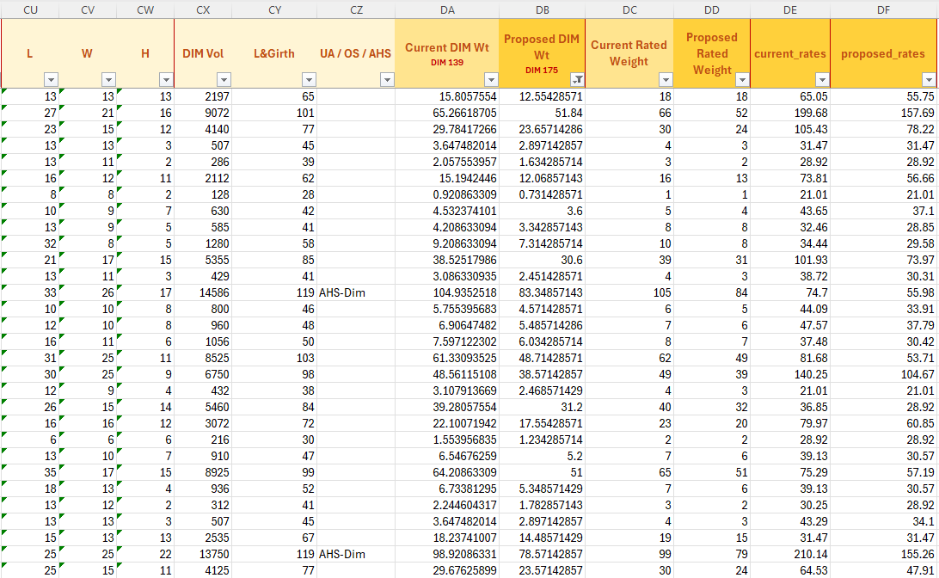
    - Below is the format present for reference

Minimum Billable Weight (MBW)
This is a Mandatory step when DIM factor changes request comes. When a shipment qualifies for certain surcharges, the MBW rule activates. This simply means the shipment's weight is bumped up to a minimum chargeable limit if existing calculated weights are less than MBW. For MBW refer to the latest year Service Guide. For FY 2026 the service guide can be referred from here - Link (Refer page no. 127 & 128)

There are 3 types of surcharges on which MBW is applied, that are: -
1. Unauthorized Weight (UA) (Applicable only on Ground, Home Delivery, Multiweight and Return Manager products)
When a package falls under a special handling category, like the 'Ground Unauthorized Package' rule, its shipping cost is determined by a preset Minimum Billable Weight. For example, even if such a package weighs 75 lbs, it will be billed as if it weighs 90 lbs. In this case the weight will be changed to 90 lbs in current and proposed weight if it is less than 90 lbs.
UA is applicable when a shipment meets any of the following criteria:-
    - Any package measuring more than 108 inches in new calculated length.
    - Any package measuring more than 165 inches in length and girth combined.
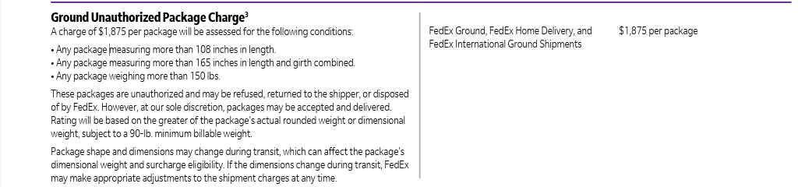
    - Any package weighing more than 150 lbs in actual weight.

- Oversize (OS)
When a package falls under a special handling category, like the ‘Oversize’ rule, its shipping cost is determined by a preset Minimum Billable Weight. For example, even if such a package weighs 75 lbs, it will be billed as if it weighs 90 lbs. In this case the weight will be changed to 90 lbs in current and proposed weight if it is less than 90 lbs.

UA is applicable when a shipment meets any of the following criteria: -
  - Measures greater than 96 inches along its calculated longest side.
  - Measures greater than 130 inches in length and girth — the length and girth is length plus (two times the height) plus (two times the width).
  - Measures greater than 17,280 inches in cubic volume (cubic volume is measured by multiplying length times width times height)
  - has an actual weight greater than 110 lbs

- AHS (Dimension and Weight)
When a package falls under a special handling category, like the ‘AHS DIM or AHS Wieght’ rule, its shipping cost is determined by a preset Minimum Billable Weight. For example, even if such a package weighs 25 lbs, it will be billed as if it weighs 40 lbs. In this case the weight will be changed to 40 lbs in current and proposed weight if it is less than 40 lbs.

  - AHS Weight is applicable when a shipment meets any of the following criteria: -
  - has an actual weight greater than 50 lbs.

  - AHS DIM is applicable when a shipment meets any of the following criteria: -
- Measures greater than 48 inches along its longest side.
- Measures greater than 30 inches along its second-longest side
- Measures greater than 105 inches in length and girth — the length and girth is length plus (two times the height) plus (two times the width);
- Measures greater than 10,368 inches cubic volume (cubic volume is measured by multiplying length times width times height)

If a shipment is applicable for multiple surcharges, the surcharge with highest amount is applied for the shipment. Check for the proposed agreement if any discount is applicable for any of the UA/OS/AHS surcharge. The below example table can be referred for prioritizing the Surcharges. Always refer Service Guide to check for the List Rates.
Surcharges | Discount applicable in proposed agreement | List Rate | Proposed Rate (List Rate *(1-Discount)
UA | 0% | 1,875 | 1,875
OS | 50% | 255 | 127.5
AHS-Wt | 50% | 46 | 23
AHS-Dim | 50% | 29.5 | 14.75

If in case the Dimension column is present as NA and the Calculated weights give values as “#NUM!”, replace the value with the actual rated weight by rounding it up in Current and Proposed rated weight column.

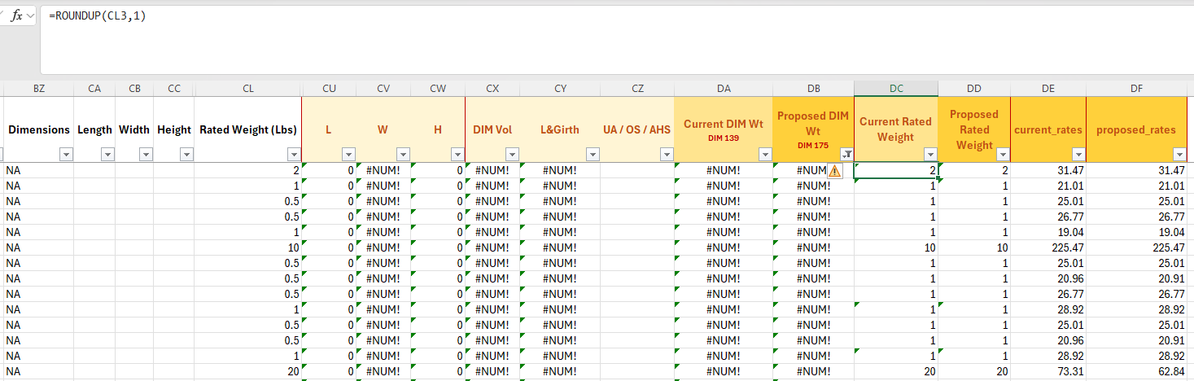

Summary should be made in the below format.
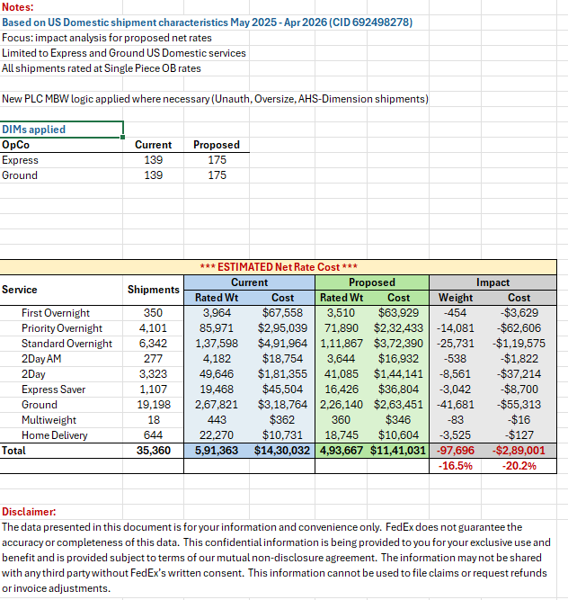

- Apply what you've learned and give it a try here:
  - COE Education - Day 10 - DIM #1
  - COE Education - Day 10 - #2
  - COE Education - Day 11 - DIM analysis

Surcharges Analysis
If the request involves surcharges, refer to these steps
- Use the 2026 Surcharge Pricing Template – Discount Comparison (Oct 2025). Input all relevant shipment data as per the request.
- Refer to the following tabs in the template based on shipment data services:
By Zone Charges, Ground, ExDom Parcel, Ground Economy (if applicable)
- Validate Discounts
Disc 1 (Current Agreement):
- Compare Disc 1 surcharge discounts against the current agreement for applicable surcharges.
- In most cases, the discount percentage should match the agreement.
- If a mismatch is found:
  - Verify using the CPM tool.
  - Update the Excel sheet manually with the correct discount %.
Disc 2 (Proposed Agreement):
- Compare Disc 2 surcharge discounts against the proposed agreement.
- In most cases, these will require manual updates to align with the proposal.
- Prepare the Surcharge Summary Table
Include impact and subtotals for both Current and Proposed costs for Express and Ground.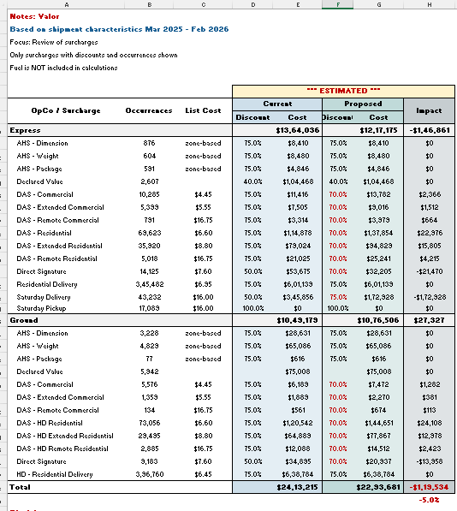
- Identify Surcharges to List Individually
List only those surcharges as separate line items:
    - Where there is a change in discount, and
    - Where occurrences are present
    - All other surcharges can be excluded from listing individually.
- Group Remaining Surcharges
Surcharges with no discount change but with occurrences should be summed together under:
“All other surcharges subject to fuel” (as per provided format snippet).
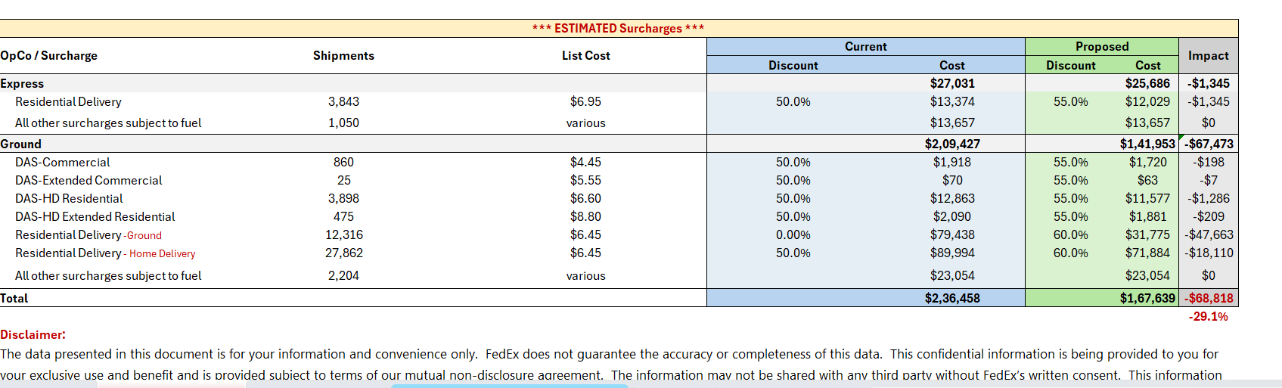
- Declared Value Surcharge
- Cost cannot be obtained directly from the template.
- Use the Surcharge Detail Template to:
  - Fetch occurrences and cost.
  - Apply current/proposed discounts.
  - Calculate final values.
- Fuel Surcharge Handling
  - Identify Applicable Surcharges: Determine which surcharges are subject to fuel (separate lists for Ground and Express).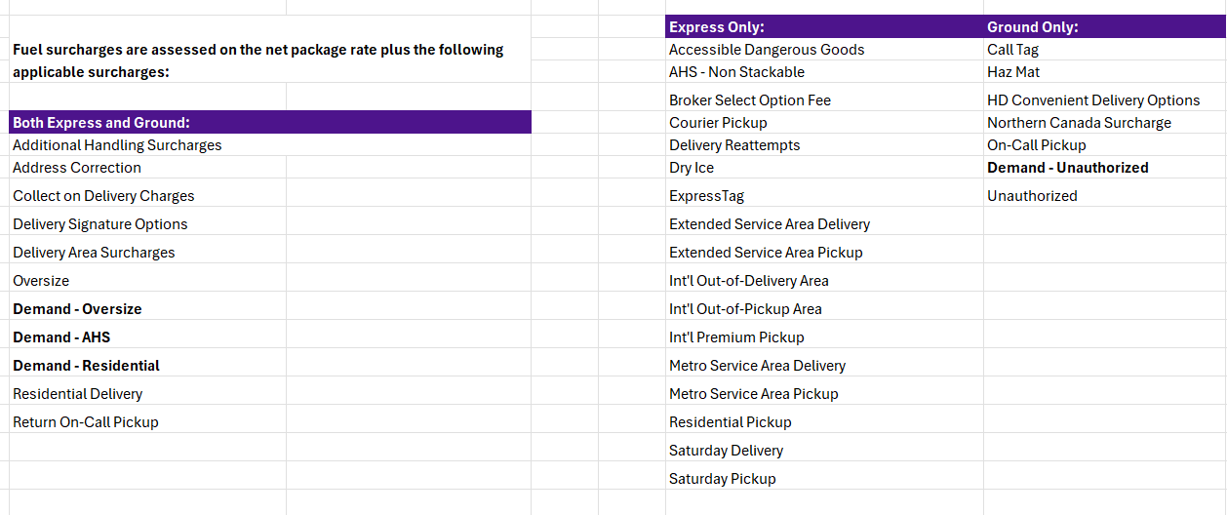
  - Check Discounts
    - Verify current and proposed agreement discounts.
    - If no discount is mentioned in the agreement, assume no discount applies.
  - Reference Latest Fuel Rates
    - Weekly fuel surcharge rates are available on FedEx Home: Weekly Fuel Surcharge Changes | FedEx
    - Use the latest week’s rate unless otherwise specified.
  - Include Supporting Tables
    - Add DIMs applied table (current vs. proposed).
    - Add Fuel Table showing rates used.
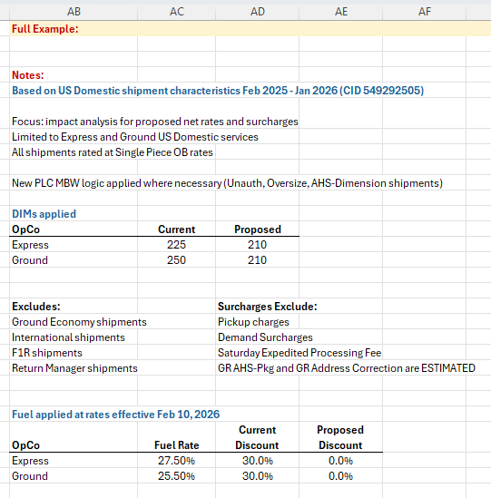
  - List Surcharges Individually
    - Only if fuel is applicable and the discount changes.
    - Remaining surcharges should be grouped into a single line item.
  - Fuel Surcharge Calculation
    - Formula:
(Total Transportation Costs + Surcharges) × Current/Proposed Discount % × Fuel Rate %
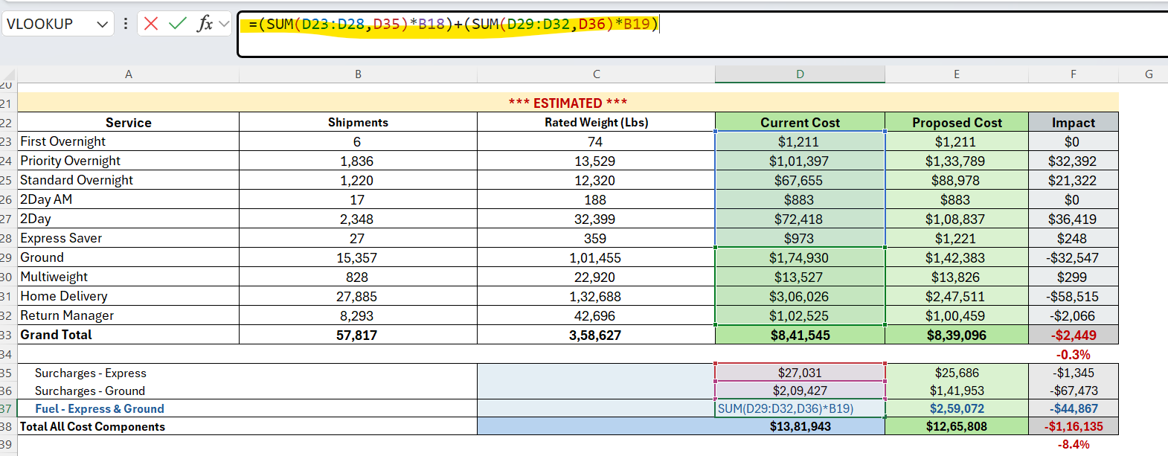
- Total Cost Impact
  - Shows the combined impact of transportation, surcharges, and fuel.
  - Formula: (Total Impact ÷ Total Current Cost).

- Annualization (If required)
- If the request specifies annualization:
- Calculate total cost including surcharges and fuel.
- Multiply by the remaining months not covered in the shipment data timeframe.
Example: If shipment data covers 4 months, multiply total costs by 6 to annualize.
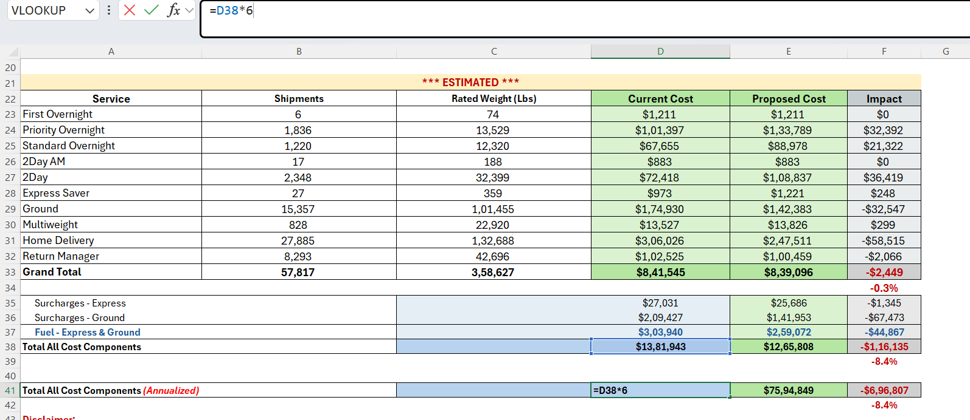

- Final Checks & Formatting
- Add Notes, Disclaimers, and Assumptions to the summary sheet.
- Ensure formatting meets expectations:
- Costs with dollars sign.
- Totals highlighted.
- Percentage impacts clearly shown.

- Apply what you've learned and give it a try here:
  - Stratasys Proposed Savings Analysis

Zone Change Analysis
When a Zone Jump/Change request comes, perform the following steps:-
- Extract the shipment data from Shipment Detail Template
- If the zone changes request comes for the Origin Zip, insert a new column besides “Actual Origin Zip” column and add the new postal code value present in the request. For calculating new zip, find the length of the zip. Depending on the length, extract the first four or five chars. If the len=9,5, extract first 5 chars, len=8,4 then first 4 chars, len=3 then 3 chars
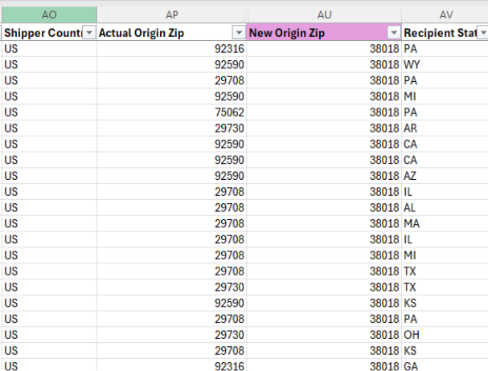

- Copy the New Origin Zip column and Destination Zip Column and paste the values in FedEx Zone Tool in “USA and or Canada Zone Lookup” tab. The Tool is present on the DART tool website.
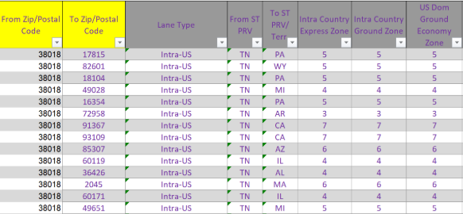

- Paste the new output Zone column obtained from zone tool besides the existing zone column in shipment data template.
- Do the rate comparison for both the zones and make summary in the following format.
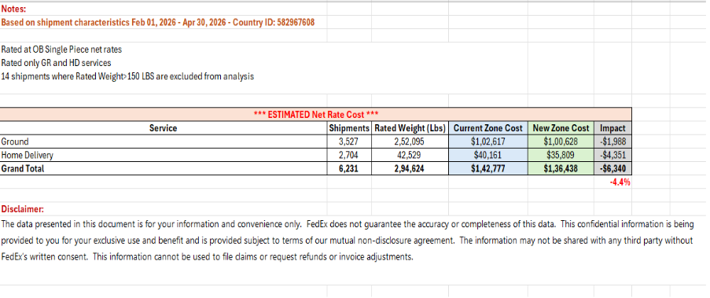
- Apply what you've learned and give it a try here:
  - Exercise File - C:\Users\8917196\Downloads\Current Rates.xlsx
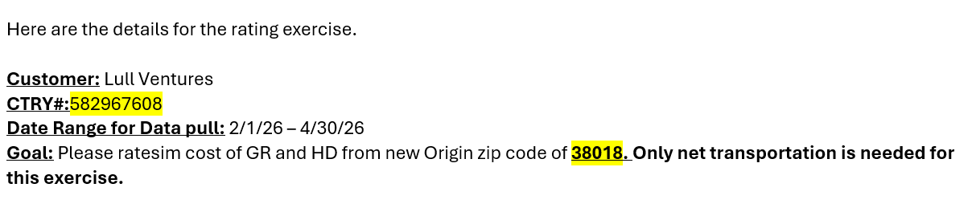
  - Solution File - https://myfedex-my.sharepoint.com/personal/forum_bhanushali_fedex_com/Documents/ER_BDA%20Rerating/Practice%20Exercises/Shipment%20Detail%20Lull%20Ventures.xlsx

Multiweight ReRating
- Complete Standard Shipment Rating
- Perform the standard shipment rating for all services, including Heavyweight and Freight shipments.
- For Ground Multiweight shipments, initially rate them using the single-piece Ground Net Rates.

- Create a Shipment Tag
- Add a new column named Tag at the end of the Shipment Data sheet.
- Generate a unique identifier for each shipment by concatenating the following fields:
  - Ship Date
  - Actual Origin ZIP
  - Recipient Address
  - Recipient Postal Code
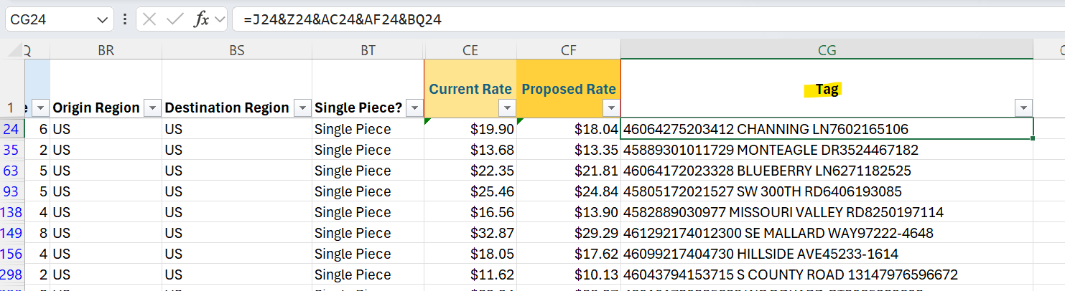

- Create MWT Calculation Worksheets
- Create two new worksheets:
  - Current MWT Calculation
  - Proposed MWT Calculation

- Create the Ground Pivot Table
- In the Current MWT Calculation worksheet, create a Pivot Table including only:
- Ground
- Ground Multiweight (MWT)
- Home Delivery (only if MWT applies per the customer agreement)

Include the following fields:

- Tag
- Zone
- Sum of Pieces
- Sum of Current Weight
- Sum of Current Cost

Repeat the same process for the Proposed worksheet using the corresponding Proposed values.
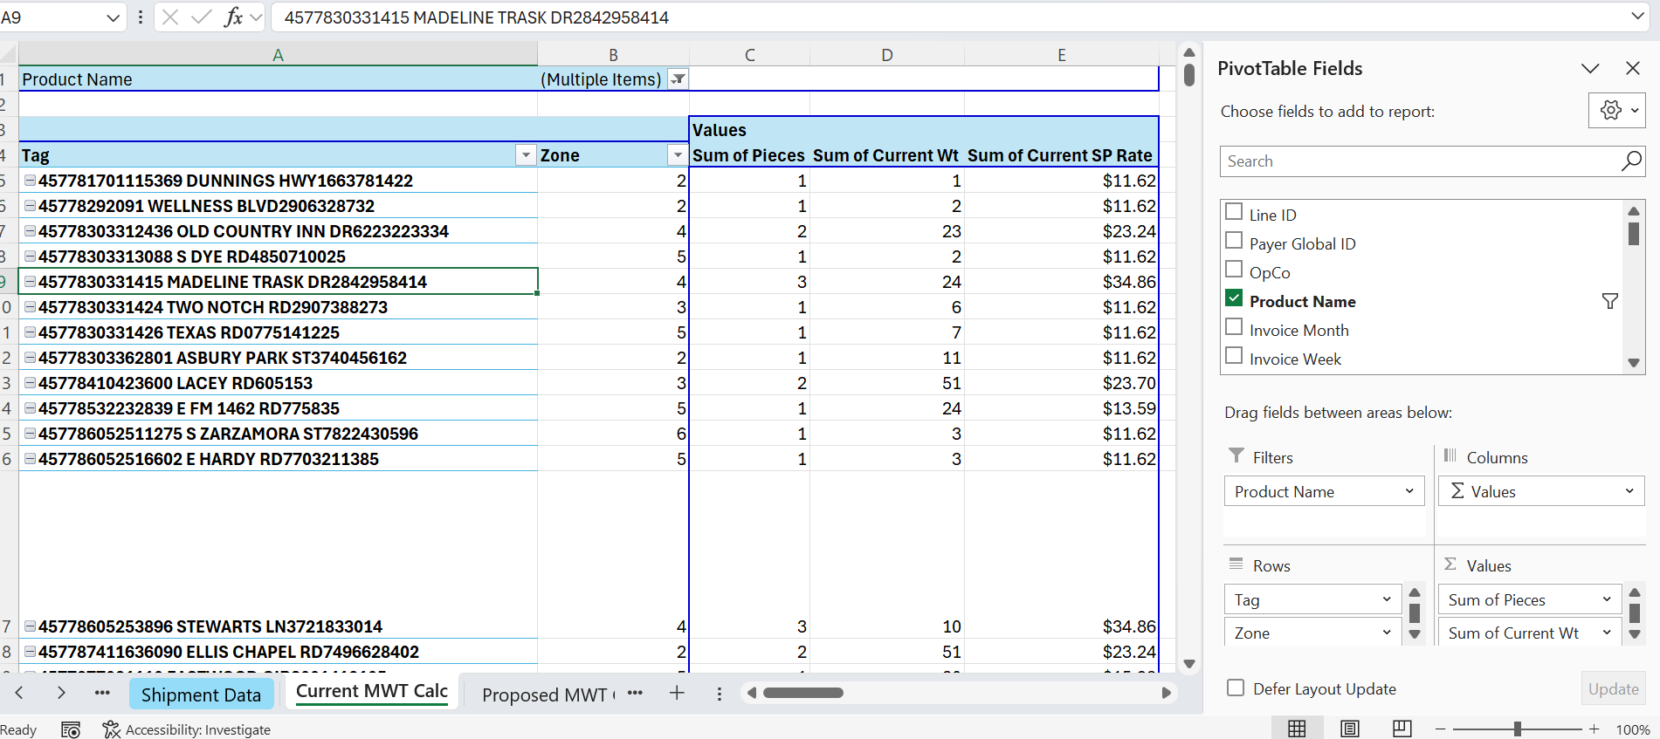

- Reference the Customer Agreement
- Locate the Multiweight Terms and Conditions within the customer agreement.
- Copy the relevant agreement section into both MWT Calculation worksheets for reference throughout the rating process.
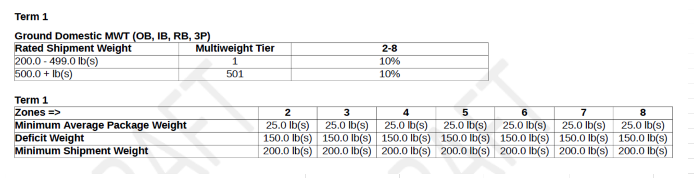
- Prepare the MWT Rate Tables
- Identify the Ground Multiweight rate tables within the Current and Proposed Net Rate Sheets.
- Locate the rows representing:
- the end of the first weight tier, and
- the beginning of the second weight tier.
- Calculate the Per-Pound Tier Rate for each identified tier by dividing the published rate by the corresponding hundredweight.
Per-Pound Tier Rate = Tier Rate ÷ Hundredweight

These values will serve as the base rates for all subsequent MWT calculations.
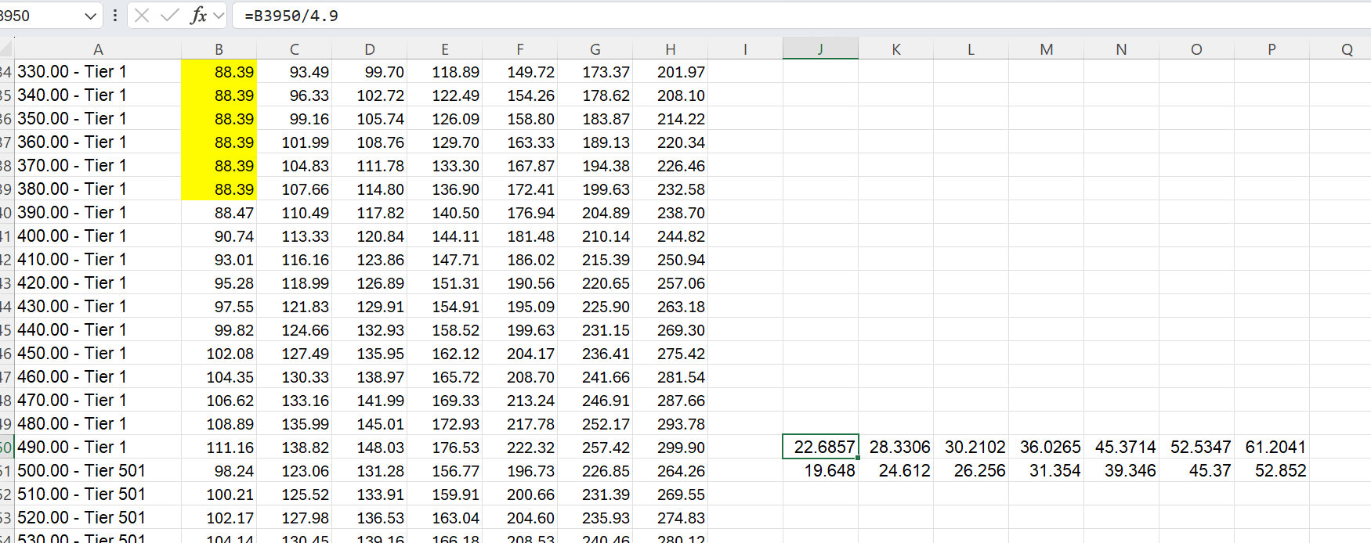

- Build the Tier-Wise Rate Table
- Create a Tier-wise rate table for Zones 2–8 within both MWT Calculation worksheets.
- Populate the table using the calculated Per-Pound Tier Rates.
- Use the applicable annual FedEx minimum charges depending on the mentioned tiers in the agreement as the Minimum Charge values (reference snippet for 2025/2026 tier-wise min charges are attached below).
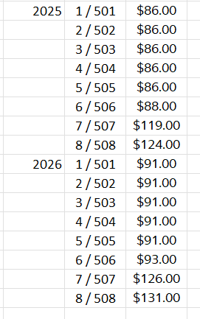

- Populate the MWT Calculation Template
- Copy the Pivot Table output into the first five columns of the MWT Calculation table template.
- Populate the remaining calculation fields using the customer agreement, including:
- Deficit Weight
- Minimum Average Package Weight
- Minimum Shipment Weight
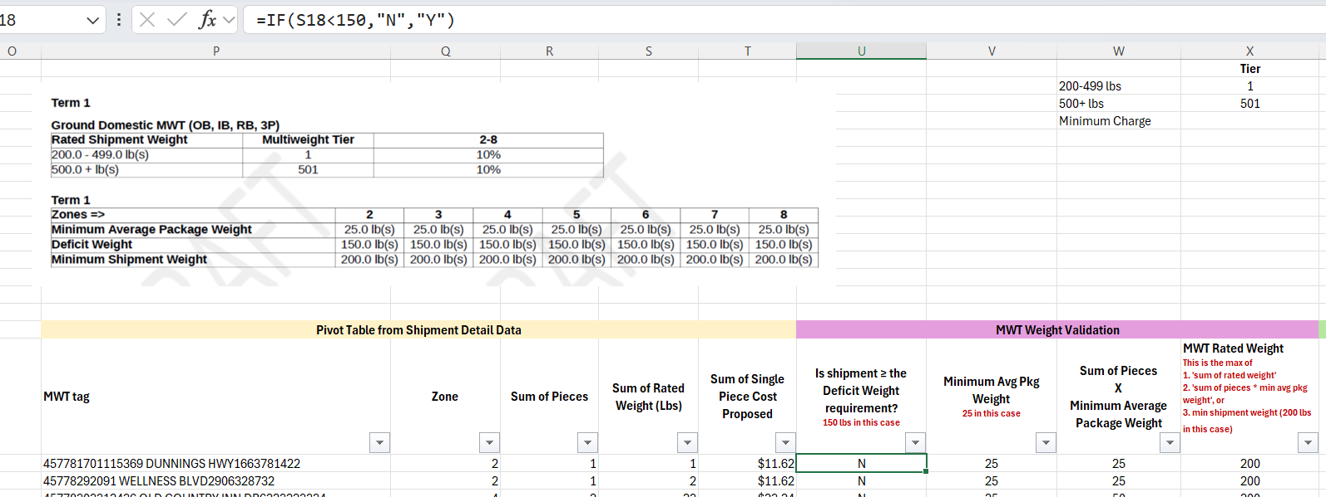

- Once all required columns have been populated in the MWT Calculation table, filter the Service column to identify the MWT shipments.

- Calculate the Cost per lb as follows:
  - MWT Shipments:
Cost/lb = Least Cost ÷ MWT Rated Weight
  - Ground (GR) Shipments:
Cost/lb = Least Cost ÷ Sum of Rated Weight (using the single-piece Rated Weight obtained from the original pivot table).
Update the formulas accordingly based on the shipment type.

- After completing the MWT Calculation table, populate the MWT Service and MWT Cost/lb columns in the Shipment Data sheet.
  - Filter the Product Service column to retain only Ground shipments.
  - Use XLOOKUP with the Tag column as the lookup value to retrieve the corresponding MWT Service and MWT Cost/lb values.
  - Repeat this process for both the Current and Proposed datasets.
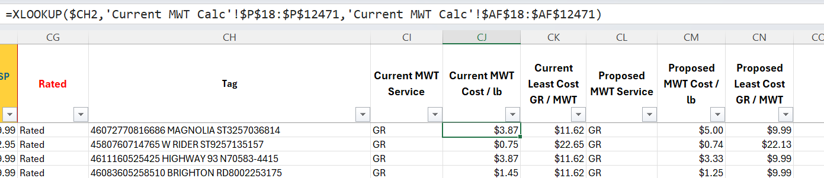

- Calculate the Least Cost for all Ground/MWT shipments by multiplying the retrieved MWT Cost/lb by the respective shipment weight:
  - Current Least Cost = Current Cost/lb × Current Weight
  - Proposed Least Cost = Proposed Cost/lb × Proposed Weight

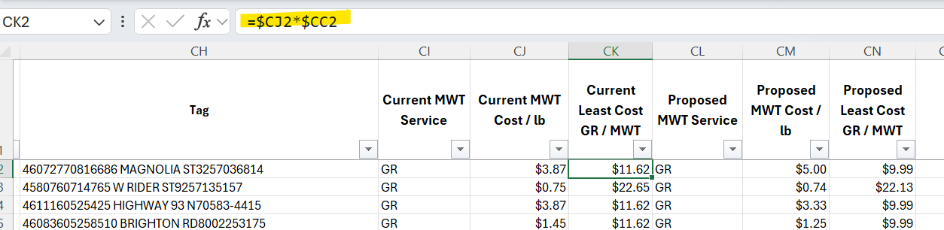

- Add a new column named Rated in the Shipment Data sheet to identify whether each shipment has been rated.
- Mark rated shipments as Rated.
- Mark unrated shipments as DNR (Do Not Rate) based on the MWT calculation results.

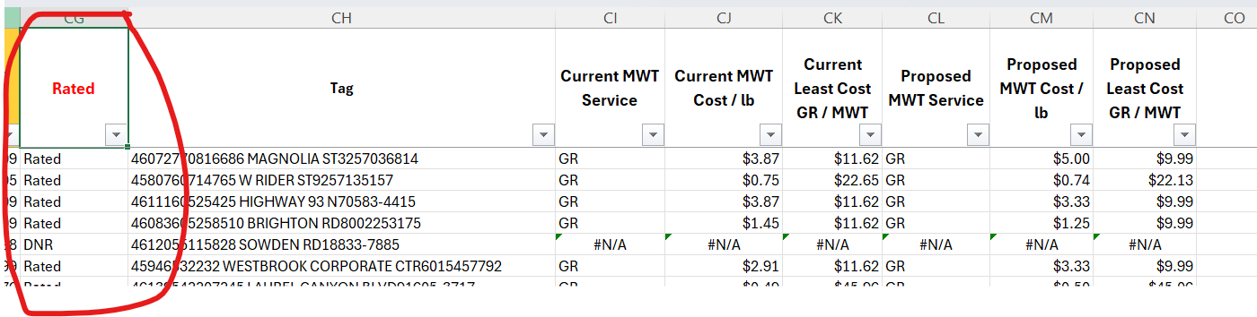

- Create the summary Pivot Tables as follows:
- Create two separate Pivot Tables for Current and Proposed Ground (GR) & MWT shipments.
- Filter the Pivot Tables to include only Rated shipments.
- Include the following values:
  - Sum of Shipments
  - Current/Proposed Weight
  - Current/Proposed Least Cost
- For all remaining services, create a separate Pivot Table using the standard summary process.
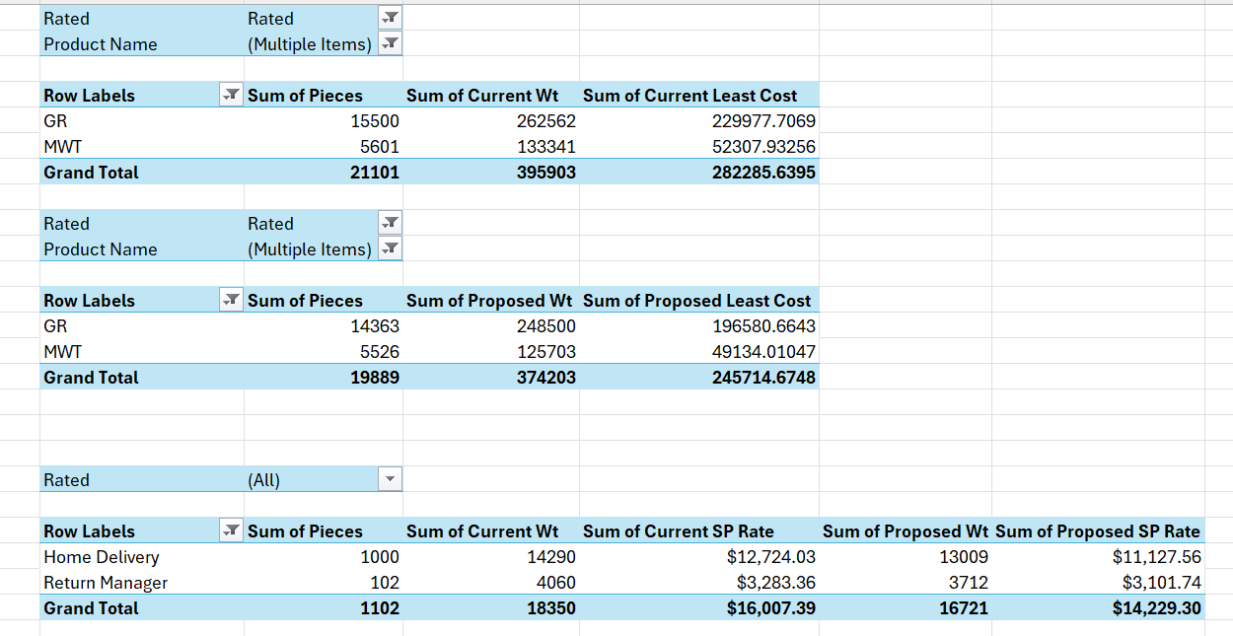

- Prepare the Summary table by arranging the services in the required reporting order and add an Impact column to calculate the variance between the Proposed and Current Least Costs.

- At the top of the Summary sheet, include:
  - The shipment data date range.
  - The CHT ID used for the analysis.

- Add any relevant notes describing shipment exclusions, assumptions, or special cases applied during the analysis.
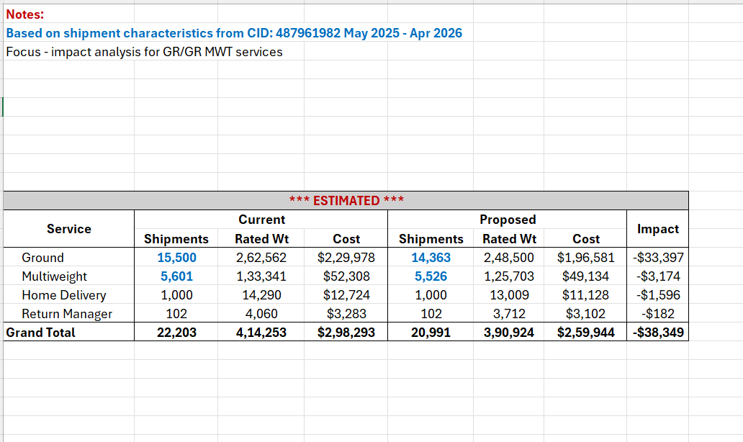

- Insert the approved Disclaimer immediately below the Summary table.

- Apply the following formatting standards:
- Display Impact (%) with one decimal place.
- Display monetary values with a $ symbol and zero decimal places.
- Follow the US numbering convention for comma separators throughout the worksheet.

Competitor Analysis – To be Added in next version
Step 1: Initial Data Review & Column Identification
Since every request or file can be formatted differently, the first step is to identify and map the required data points.
- Review the file and locate the columns that represent:
- Service / Product Name
  - Sender Details (Postal Code / Zone)
  - Recipient Details (Postal Code / Zone)
  - Dimensions (Length, Width, Height)
  - Weight (Entered Weight / Billed Weight)
Step 2: Service Mapping
- Using the identified Service/Product Name column, map the competitor's service to the equivalent FedEx service.
- Use the Service Mapping Lookup File to complete this step accurately.
Step 3: Zone Determination
Calculate the FedEx zone for each shipment using the sender and recipient details.
- Standard Method: Normalize the sender and recipient postal codes, then input them into the Zone Tool to get the FedEx zone.
- Fallback Method (Missing Postal Codes): If postal codes are not available, use the Zone Lookup File to find the zone.
Important Note: Pay special attention to shipments where Zones > 10, as these may require special handling.
Step 4: Data Formatting & Consolidation in case of row level data
When shipment details and surcharges are recorded on separate rows for the same Tracking Number, Combine the needed data before calculating rated weight.
- Look for repeated Tracking Numbers where One row has shipment details, Other rows have surcharges or dimensions
- Choose Dimension Source. Use this order- Package Dimensions, Key Dimensions, Entered Weight
- Step 3: Pull Dimensions to Main Row. Use a helper column to bring dimensions onto the main row:
INDEX($AG:$AG,MATCH(1,($U:$U=U27)*($AG:$AG<>""),0))
U - Tracking Number, AG - dimension data (e.g., Package Dimensions)
- The formula searches all rows with the same Tracking Number and returns the first non-blank dimension value.
- Repeat the same process for the Key Dimensions column, if applicable.
- Calculate Rated Weight - Use Package Dimensions if available, Otherwise use Key Dimensions, If both are blank, use Entered Weight
Step 5: Weight & Dimension Calculation
Determine the final rated weight based on the dimensions and provided weight. Follow the rules below based on the data available:
- Scenario A: Dimensions & Entered Weight are available
  - Calculate the Dimensional (DIM) Weight using the provided L, W, H.
  - Compare the DIM Weight to the Actual (Entered) Weight. Use the standard weight calculation process to determine the higher value.
- Scenario B: No Entered Weight is provided
  - Use either the Billed Weight or the Dimensional Weight in place of the entered weight.
  - Note: The choice depends on what is known about the DIM. Always document which method you used in the Summary Notes.
- Scenario C: No Dimensions are provided
  - Use the Billed Weight as the final weight. This ensures that any Minimum Billable Weight (MBW) items are potentially captured.
Note: If there are any dimension changes during this process, make sure to calculate the Minimum Billable Weight (MBW).
Step 6: Cost Calculation
Now that you have the Zone, Service, and final Weight, you can calculate the cost.
- Proceed with the normal single-piece cost calculation using the provided Net Rates.
Step 7: Surcharge Evaluation & Calculation (If Requested)
Identify and calculate any applicable surcharges based on the shipment profile and customer agreement.
- Dimensional Surcharges (If MBW is included): Identify shipments that have:
  - AHS (Additional Handling Surcharge)
  - OS (Oversize)
  - UA (Unauthorized)
- Other Common Surcharges: Look for Address Correction, Fuel Surcharges, or any other applicable fees.
- Costing & Discounts:
  - Look up the cost for each surcharge in the Service Guide.
  - Check the Customer Agreement for specific discounts.
  - Apply the discounts to the cost to get the final net surcharge cost.
Step 8: Total Cost Calculation
- Sum up the Cost (from Step 6) and all applicable Net Surcharges (from Step 7) to get the Total Cost per shipment.
Step 9: Create the Summary
Create a final "Summary Tab" to present the findings and document all assumptions made during the process.
- Assumptions: Explicitly mention every assumption made (e.g., rules used for missing weights/dims, surcharge discount applications, calculation methods chosen).
- Summary Table: The final output table must include:
  - Service
  - Total Packages / Shipments Count
  - Weight
  - Base Cost
  - Breakdown of all Surcharges

4. Troubleshooting
- Missing/Incorrect Net rates for services in the shared net rate files.

5. Additional Information
  - Tips & Tricks
Basics of Zone – What is definition of Zone and how pricing changes as per the zone? Higher the zone, higher the price. Zone is calculated basis the customer’s origin location to destination. And the zone is identified basis the distance between origin and destination.
How does zone mapping help business ? Lets say customer has 3 distribution centers.
They could have one in Texas, California and New Jersey. And let's say all most of their Imports come into California, so to get from California over to Jersey is going to be probably a Zone 7. But if they can reroute, maybe to have half those packages delivered in Jersey. Then they're shipping out from the DCS would be a lesser zone. Sometimes we have customers say we've got these three distribution centres we want to reduce that footprint to two or we want to add one more. What's the best place to put that new centre or which one should we removed to reduce? We come into play with where they place their distribution centres or where they ship out of.
Anything lower than pound is sub pound or ounce
Sometimes zones can be alphabetical too, eg 17(A) Alaska, 9 (H) Hawaii. We need translation here.
Ship day of week column might be required in some cases when BDA does analysis related to Saturday Sunday
  - Reference Links
BDA Requests - BDA Requests - COE_Requests – Request Tracker

  - FAQ
ER-BDA Re-rating QnA Tracker.xlsx

  - Reference Attachments

COE Education Roadmap
COE Manual Rating Education - Jan 2026 - Day 7
COE Manual Rating Education - Jan 2026 - Day 6
Reference Material day 7https://myfedex-my.sharepoint.com/personal/forum_bhanushali_fedex_com/Documents/ER_BDA%20Rerating/Reference%20Material.xlsx
COE Manual Rating Education - Jan 2026 Day 1

6. Revision History
Maintain a record of all updates made to the document to ensure traceability and compliance. Include version numbers, change descriptions, authors, approvers, and release dates.
Update date | Version# | Author | Approver | Description of Change
05/15/2026 | v1.1 | Aadya/Vishal | Approver’s name | Creation of document
06/15/2026 | v1.2 | Aadya/Vishal | Approver’s name | Restructured the document along with addition of zone jump topic

